
  - How to Update an Address Block
This guide provides parents with step-by-step instructions for updating their address within the Parent Orbit app.
STEP 1 |  |  | STEP 2
On the homepage, you will see a series of tabs down the bottom of the screen.  Tap ‘Profile’. | 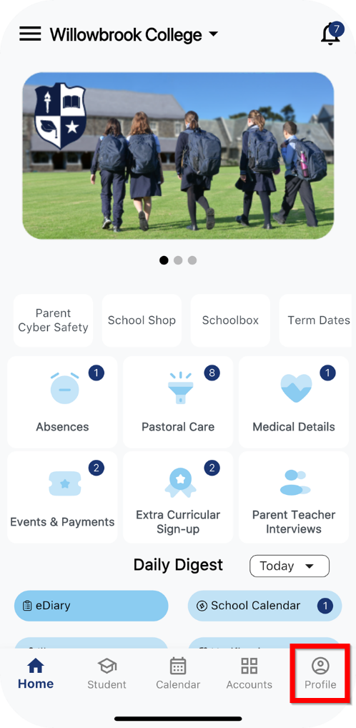 |  | On the Profile tab, you will see a list of sections.  Tap ‘Address Details’. | 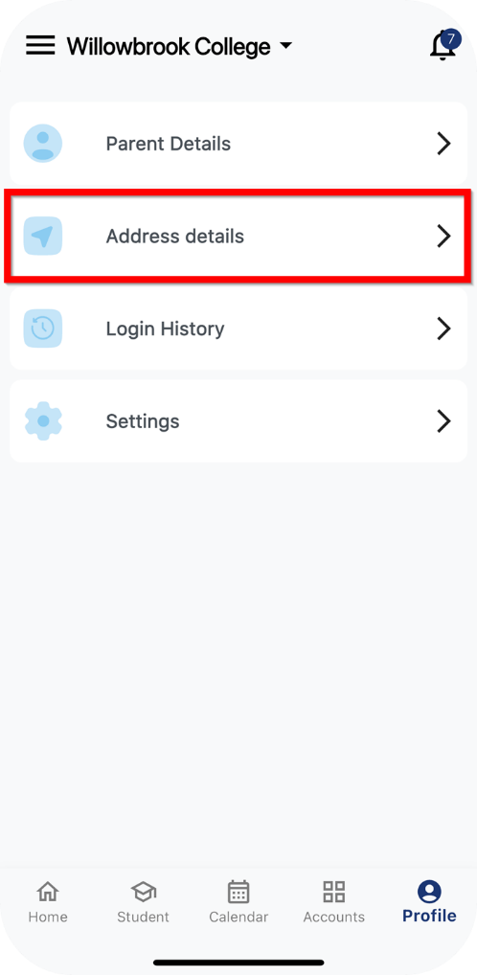

STEP 3 |  |  | STEP 4
On the Address Details page, along the top of the screen you will see address blocks associated with your account, in a side-scrollable menu.  As per your school’s setup, your school defines which address blocks are available to be updated on the app. If it is not updatable via the app, you will need to contact your school.  On the address blocks that you can update, you will see an ‘Update Address’ button down the bottom of the page.  Tap ‘Update Address’. | 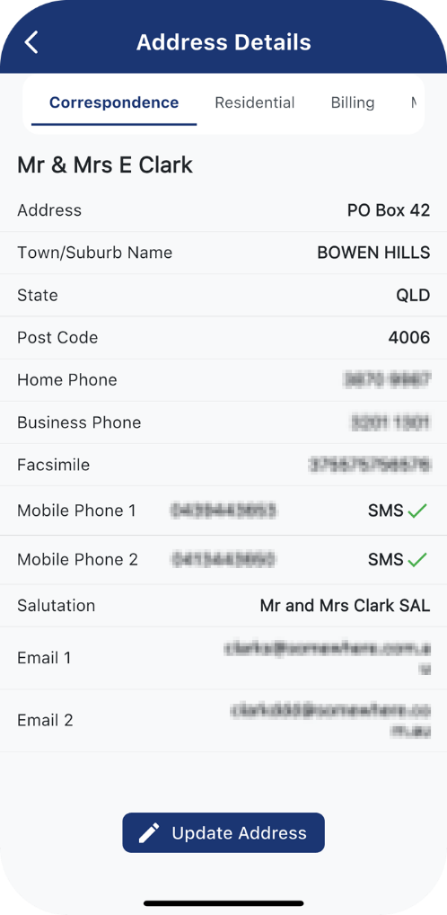 |  | On the Update Address Details page, you will see a form you can fill out to update your details. E.g. name, address, phone numbers, SMS preferences, email addresses, etc.  Tapping into each field will bring up your device's keyboard to enter in new details or override existing ones.  After you have entered any updates, tap ‘Submit’. | 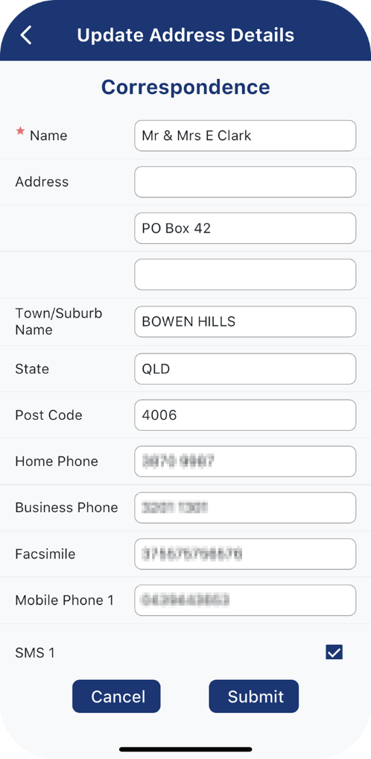

STEP 5 |  |  | STEP 6
Submitting the update will send a request to your school to review and approve the update.  While the update is pending, a ‘red warning’ icon will display beside the name on the Address Details page.  Once the update has been approved, the new details will be visible under Address Details on both Parent Orbit and Parent Lounge. | 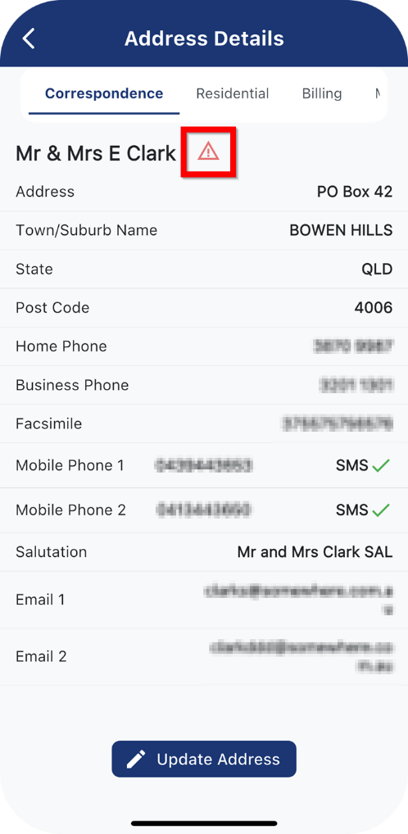 |  | While the update is still pending, if you tap ‘Update Address’ again, the Update Address Details page will display a warning at the top:  In our example, we had updated the Address, Town/Suburb Name and Post Code fields. These are indicated by the ‘red warning’ icon beside each field.  Any updates made to these same fields will override existing updates awaiting review. Changes to other fields will be added to the pending updates for review. | 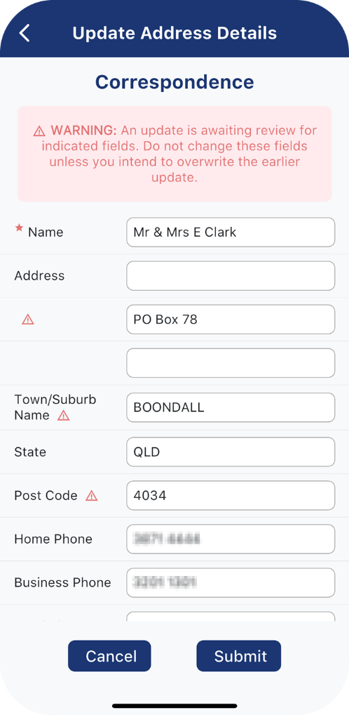
   | WARNING: An update is awaiting review for indicated fields. Do not change these fields unless you intend to overwrite the earlier update.

