
  - How to Download and Install the Parent Orbit App
This guide is designed to help parents easily download, install, and log in to the Parent Orbit app for the first time on their mobile device.
Please note: The guide has been put together with screenshots from Apple iPhone, the steps will be very similar for Android devices.
STEP 1 |  |  | STEP 2
To download the app, on your mobile device go to your school’s School Code link or scan the QR code.  This will open a page in your device’s web browser.  Make sure the ‘Save my place in the app. A link will be copied to continue to this page.’ checkbox is ticked.  Tap ‘Open’. | 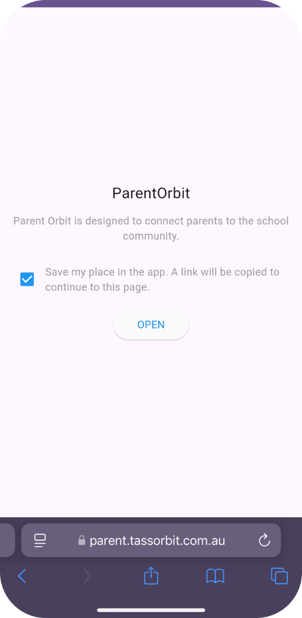 |  | You will be directed to the Apple App Store or Google Play store.  Tap ‘Install’.  After the app has installed, tap ‘Open’. | 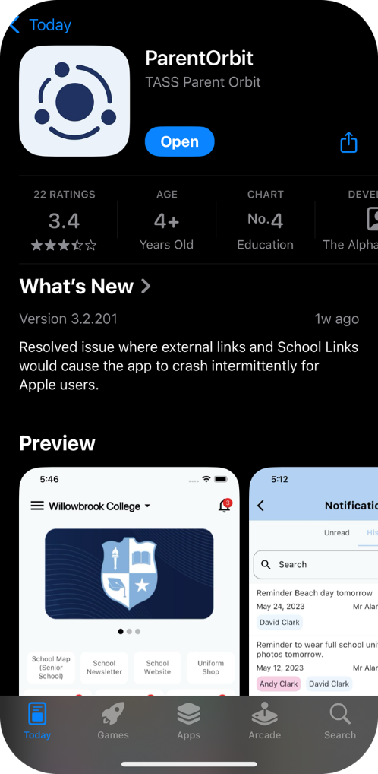
   | If you do not have your school’s School Code link or QR code, please go to the Apple App Store or Google Play store and search ‘Parent Orbit’.

STEP 3 |  |  | STEP 4
You will be directed to the Parent Orbit app.  On iPhone: A dialogue box will appear ‘“Parent Orbit” would like to paste from “Safari” Do you want to allow this?”'  Tap ‘Allow Paste’.  On Android: Your school’s account will automatically be added to the app. | 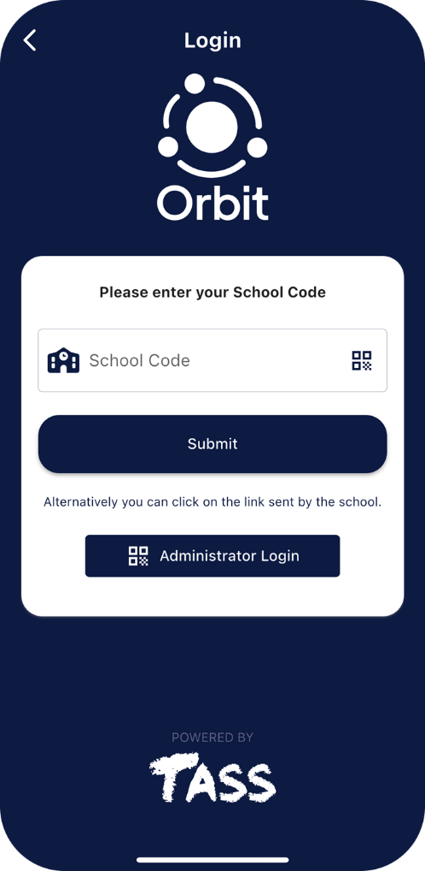 |  | Your school’s account will be added to the app.  Tap on ‘your school’s name’. | 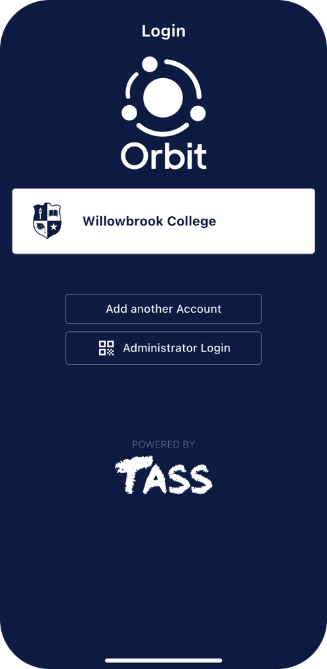
  If your school does not automatically add to the app, you may need to manually type in your school code.
  Your school code will be the end of the school link, e.g.: https://parent.tassorbit.com.au/[SCHOOL CODE]
  If you do not know your school code or link, you will need to contact your school.

STEP 5 |  |  | STEP 6
You will see the login screen.  Enter your Parent Orbit username and password, these will be the same login details that you use for Parent Lounge. | 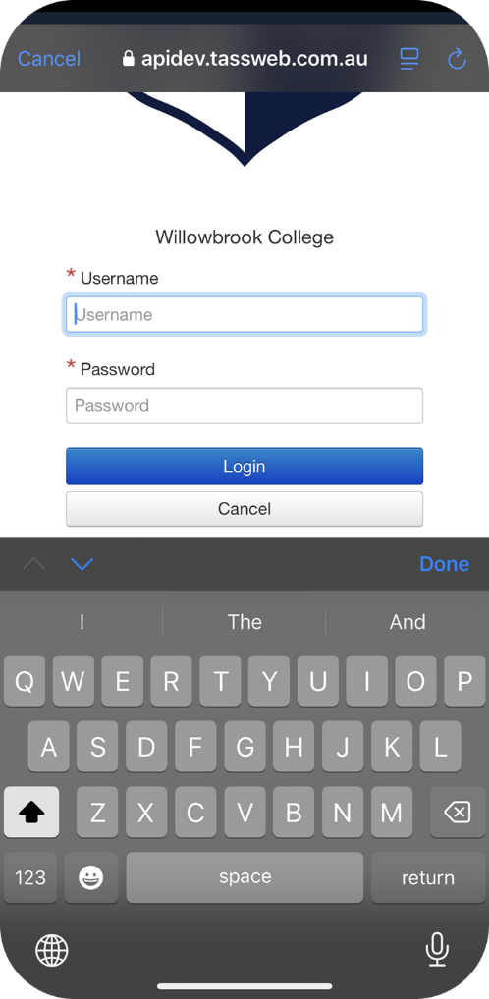 |  | You will now see your school’s homepage! | 