

  - How to Acknowledge an Absence
This guide provides parents with step-by-step instructions on how to acknowledge an absence in the Parent Orbit app.
STEP 1 |  |  | STEP 2
There are two main locations you will find absences that are required to be acknowledged.  On the homepage, the ‘bell’ icon in the top right corner will show a number indicating all unread Notifications that have recently been sent to you.  Also, the ‘Absences’ tile will show a notification bubble indicating how many absences have not been acknowledged.  Tap the ‘Absences’ tile. | 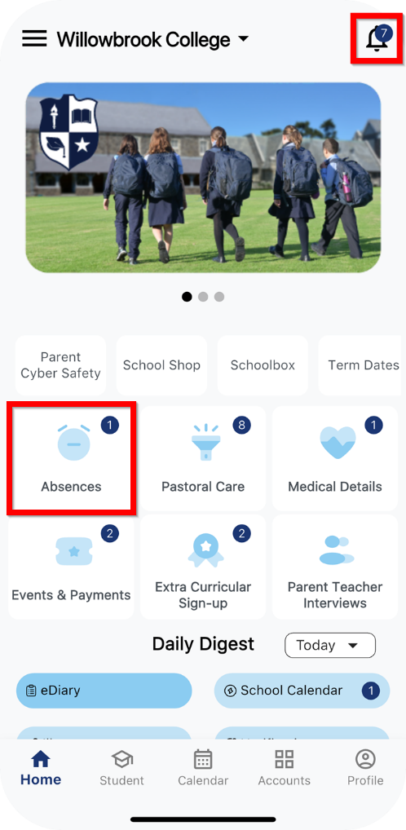 |  | This page will show you a list of ‘Absences requiring your acknowledgement’ and ‘My Submitted Absences’.  Tap the absence record you would like to acknowledge.  In our example, we are tapping ‘Late for School - Andy Clark - Mar 07, 2025’. | 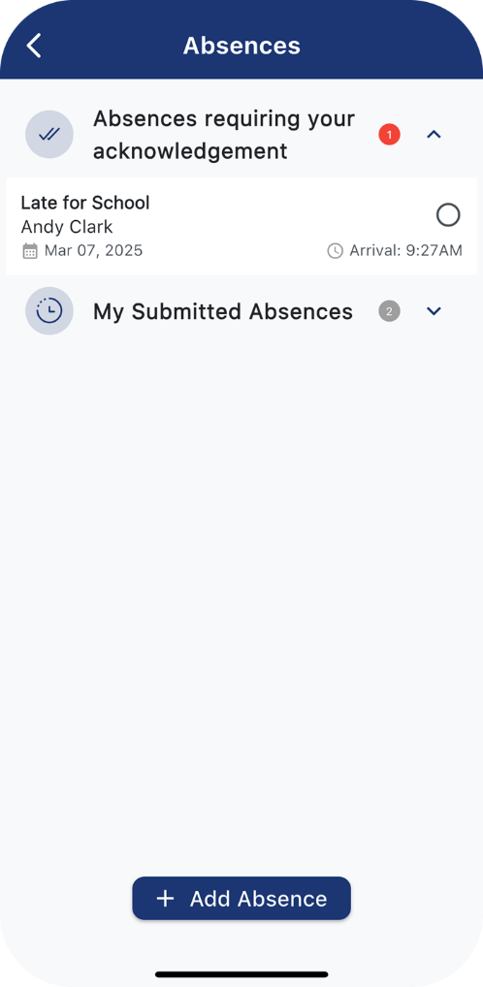

STEP 3 |  |  | STEP 4
This will bring up the Acknowledge Absence screen.  You will see:  - The student’s name  - The date they were absent  - The absence type  Tap ‘Reason for Absence’. | 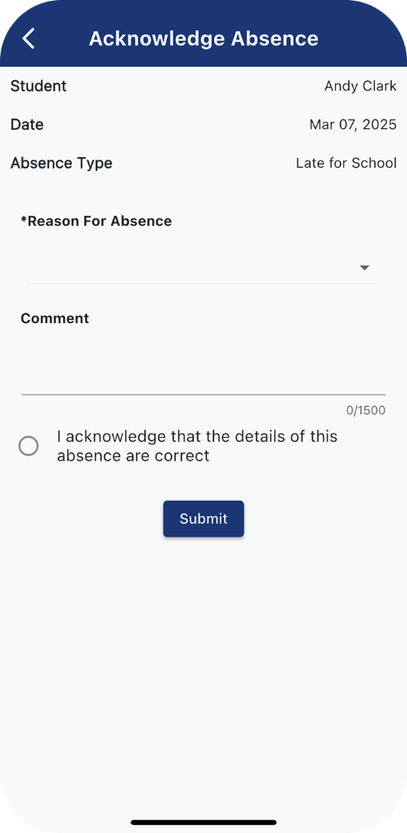 |  | This will display a drop down list so you can select a reason for their absence.  In our example, we are tapping on ‘Doctors Appointment’ as our reason for Andy being late for school. | 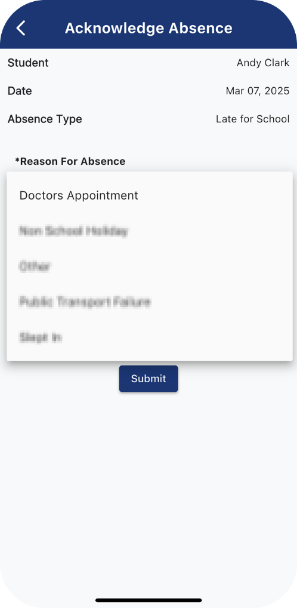
   | Please note, your school will have defined a list of absence reasons for you to choose from.  The 'Reasons for Absence' available to you may differ from our example.

STEP 5 |  |  | STEP 6
There is also a ‘Comment’ section where you can enter any comments or additional information regarding the student’s absence.  Depending on your school’s requirements, entering a comment might be mandatory.  In our example, we have said ‘Andy had a doc appt this morning.’  Mark the ‘I acknowledge that the details of this absence are correct’ radio button to confirm that you have reviewed the absence details you have provided are correct.  Tap ‘Submit’. | 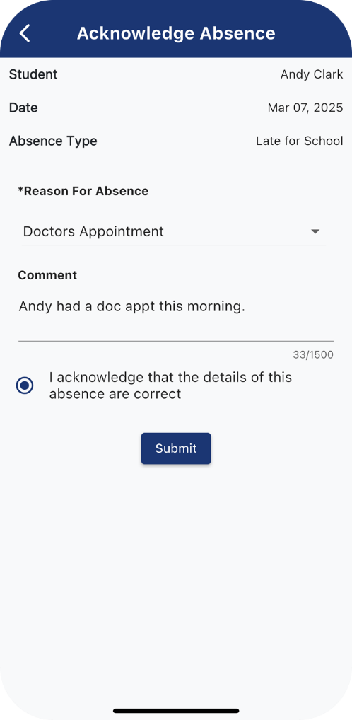 |  | This will return you to the ‘Absences’ screen.  As you can see, there are no longer any absences requiring your acknowledgement. | 